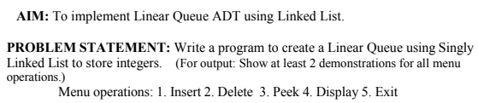

#include <stdio.h>
#include <stdlib.h>
struct Node {
int data;
struct Node* next;
};
struct Node* fronT= NULL;
struct Node* rear = NULL;
void insert(int val) {
struct Node* ptr = (struct Node*)malloc(sizeof(struct Node));
ptr->data = val;
ptr->next = NULL;
if (front == NULL) {
front = rear = ptr;
} else {
rear->next = ptr;
rear = ptr;
}
printf("Inserted %d\n", val);
}
void delete() {
if (front == NULL) {
printf("Underflow\n");
return;
}
struct Node* ptr = front;
printf("Deleted %d\n", ptr->data);
front = front->next;
free(ptr);
if (front == NULL) {
rear = NULL;
}
}
void peek() {
if (front == NULL) {
printf("Queue is empty\n");
} else {
printf("Front element: %d\n", front->data);
}
}
void display() {
struct Node* ptr = front;
if (front == NULL) {
printf("Queue is empty\n");
return;
}
printf("Queue: ");
while (ptr != NULL) {
printf("%d ", ptr->data);
ptr = ptr->next;
}
printf("\n");
}
int main() {
int choice, val;
while (1) {
printf("\n1. Insert\n2. Delete\n3. Peek\n4. Display\n5. Exit\nEnter choice: ");
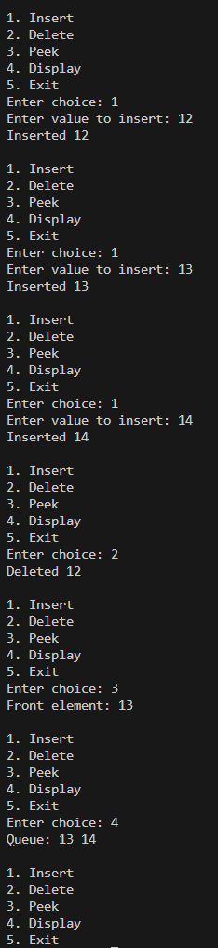
scanf("%d", &choice);
switch (choice) {
case 1:
printf("Enter value to insert: ");
scanf("%d", &val);
insert(val);
break;
case 2:
delete();
break;
case 3:
peek();
break;
case 4:
display();
break;
case 5:
exit(0);
default:
printf("Invalid choice\n");
}
}
return 0;
}

